EduGenie – Google Gemini Powered Learning Assistant
Project Design Phase
Solution Architecture
Date | 28/09/2026
Team ID | SWTID-2026-EG01
Project Name | EduGenie
Submitted by: Rahul R | Mentor: Sasi B
Solution Architecture:
The solution architecture for EduGenie focuses on a lightweight, modular backend built with FastAPI, Jinja2, and Uvicorn, paired with a hybrid AI layer that splits work between a local lightweight model and Google's cloud-based Gemini 1.5 Pro.
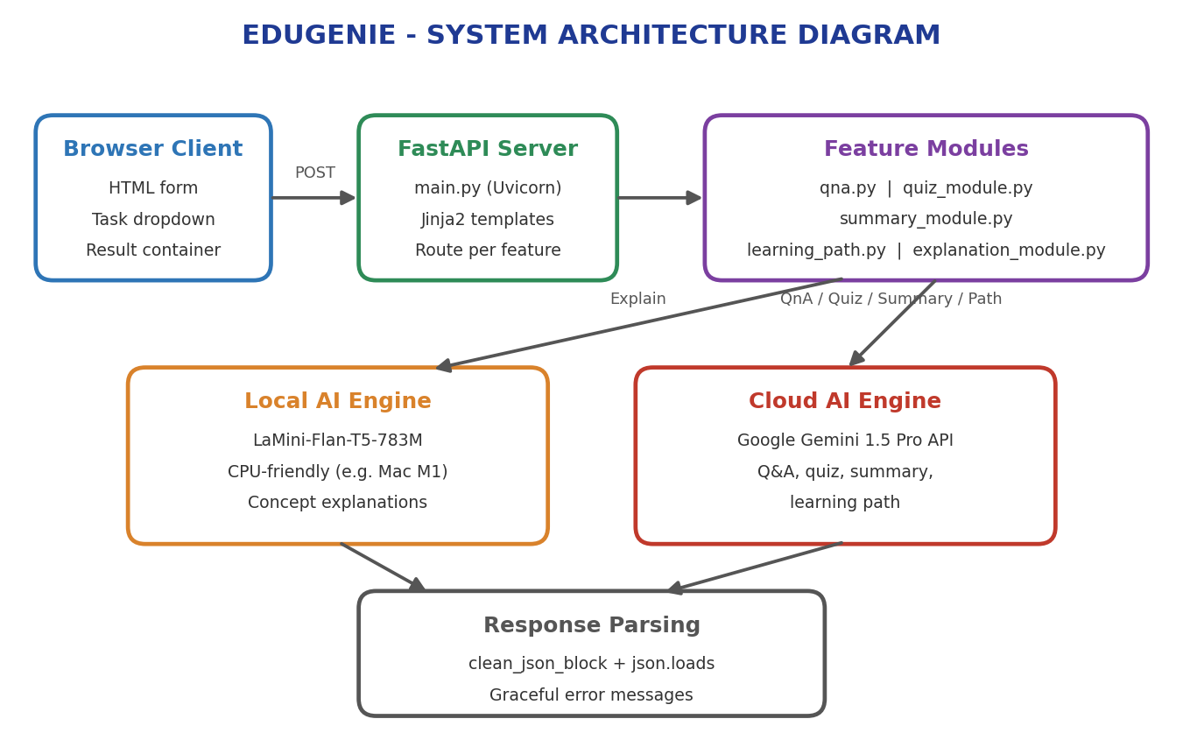
Goals of the Solution Architecture:
Identify the Best Tech Solution:
- Use FastAPI, Jinja2, Uvicorn, a local LaMini-Flan-T5 model, and the Google Gemini 1.5 Pro API to build a fast, accessible educational assistant.
Define Structure & Characteristics:
- Follow a modular, one-file-per-feature architecture to ensure maintainability, clarity, and easy extension with future learning features.
Outline Features & Development Phases:
- Plan development across model selection, core module implementation, backend API wiring, frontend integration, and deployment/testing for a stable release.
Establish Specifications for Development & Delivery:
- Define consistent REST endpoint conventions (/qa, /explain, /quiz, /summarize, /learn/recommendations), structured JSON handling for AI output, and graceful error handling across all modules.

